OS-LAB ASSIGNMENT-03
- Write a shell script to display current date in a particular format, number of users currently login and current month’s calendar.

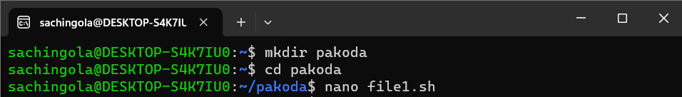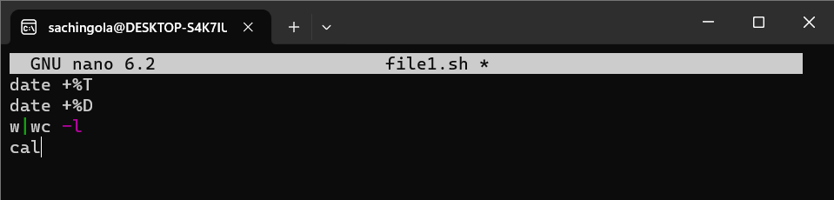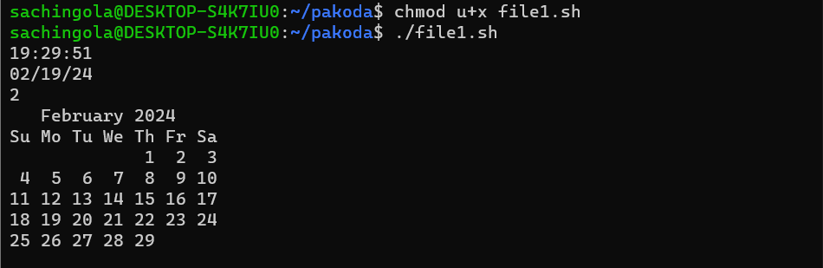

- Write a shell script to display the process name and its process id.

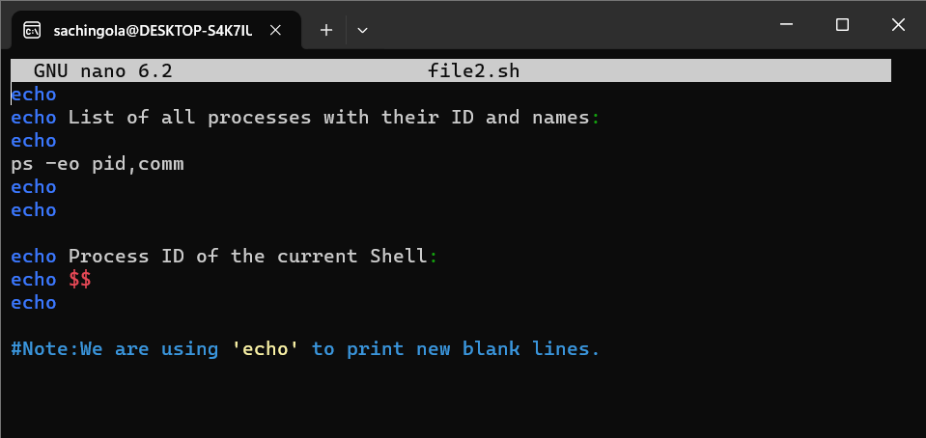
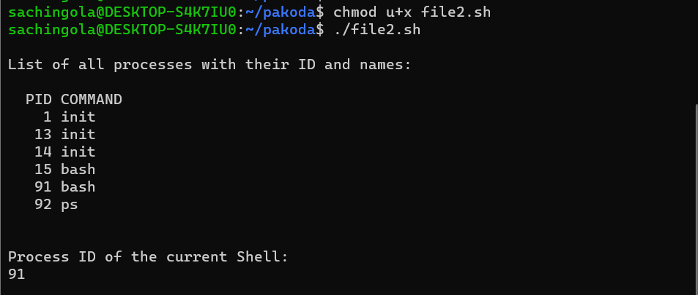

- Write a shell script to take name as a input and display a greeting message to the user by checking system clock.

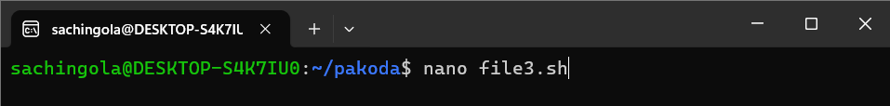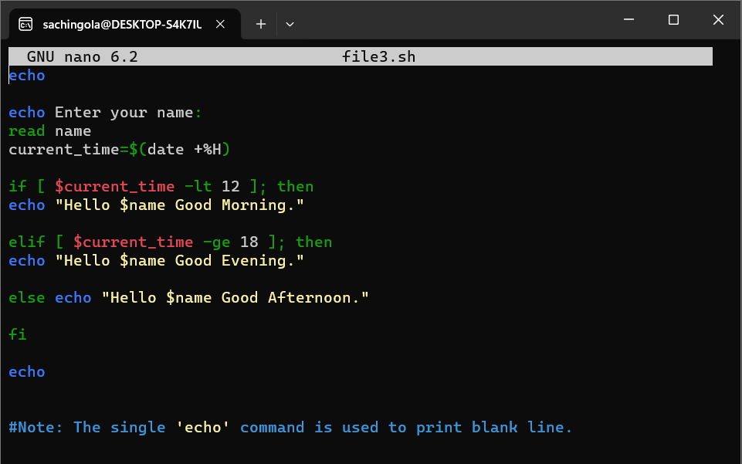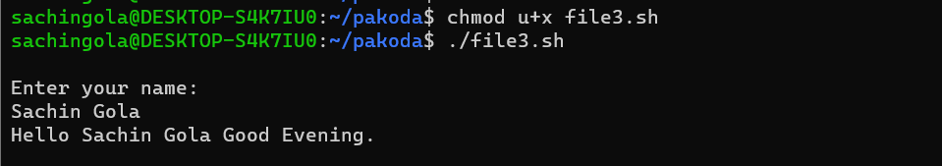

- Write a shell script to merge the content of 2 files into one file.

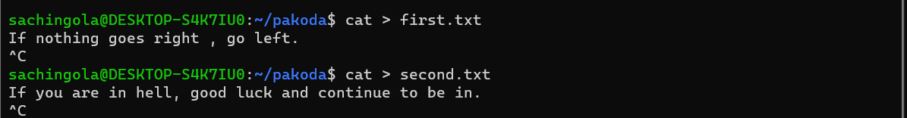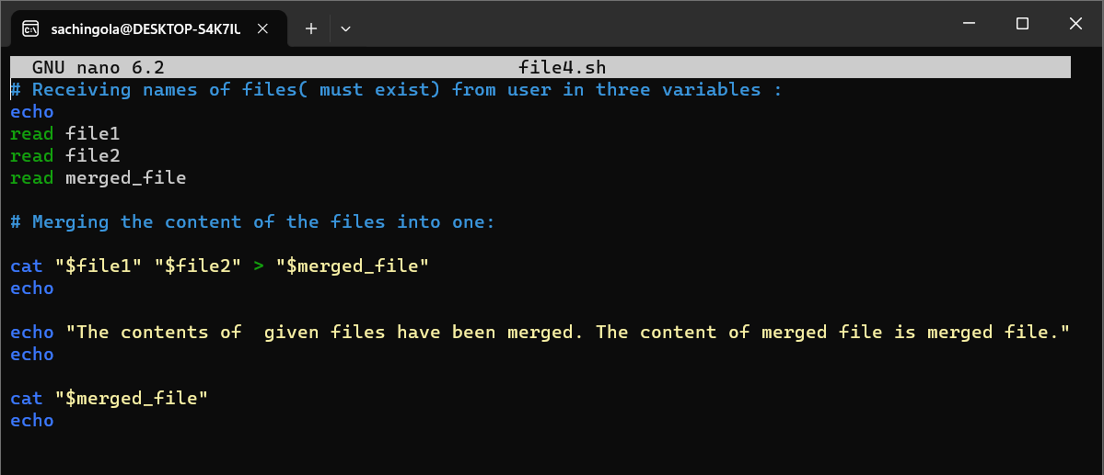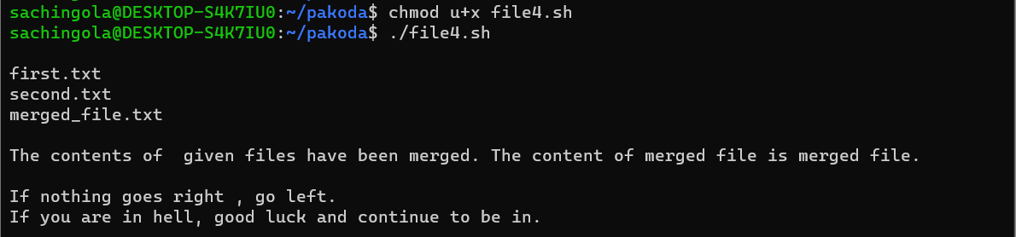

- Write a shell script to create a tsv file containing name, roll no. and age of 10 students. Then use that tsv file to display only the names of the students in alphabetical order.

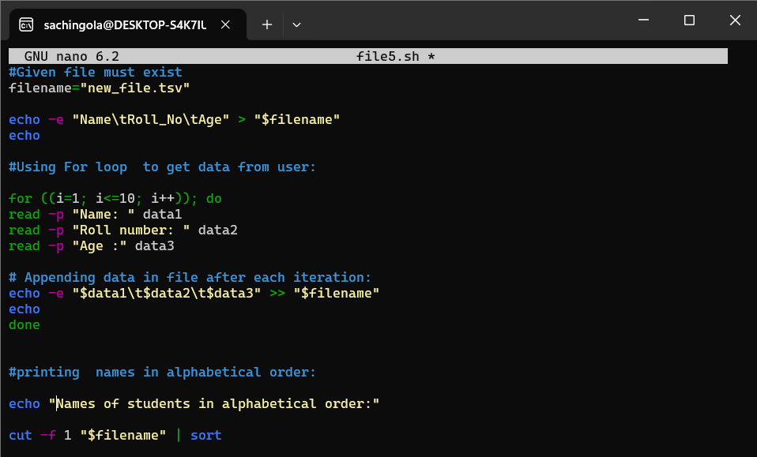

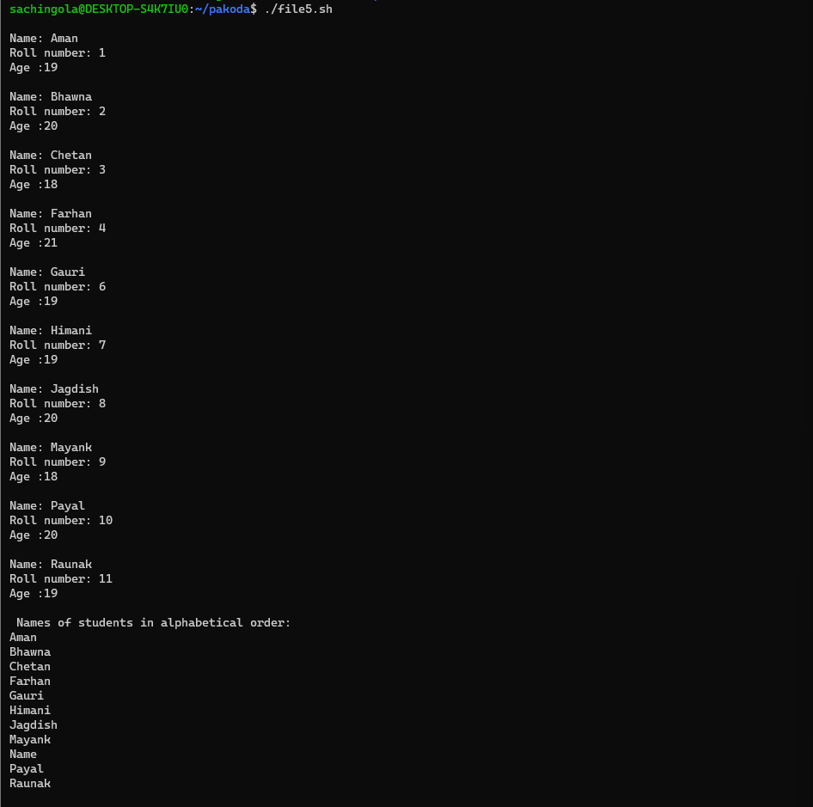

- You are given a file of tab-delimited weather data (TSV). There is no header column in this data file. The first five columns of this data are: (a) the name of the city (b) the average monthly temperature in Jan (in Fahrenheit). (c) The average monthly temperature in April (in Fahrenheit). (d) The average monthly temperature in July (in Fahrenheit). (e) the average monthly temperature in October (in Fahrenheit).You need to sort this file on the basis of average monthly temperature in April.

